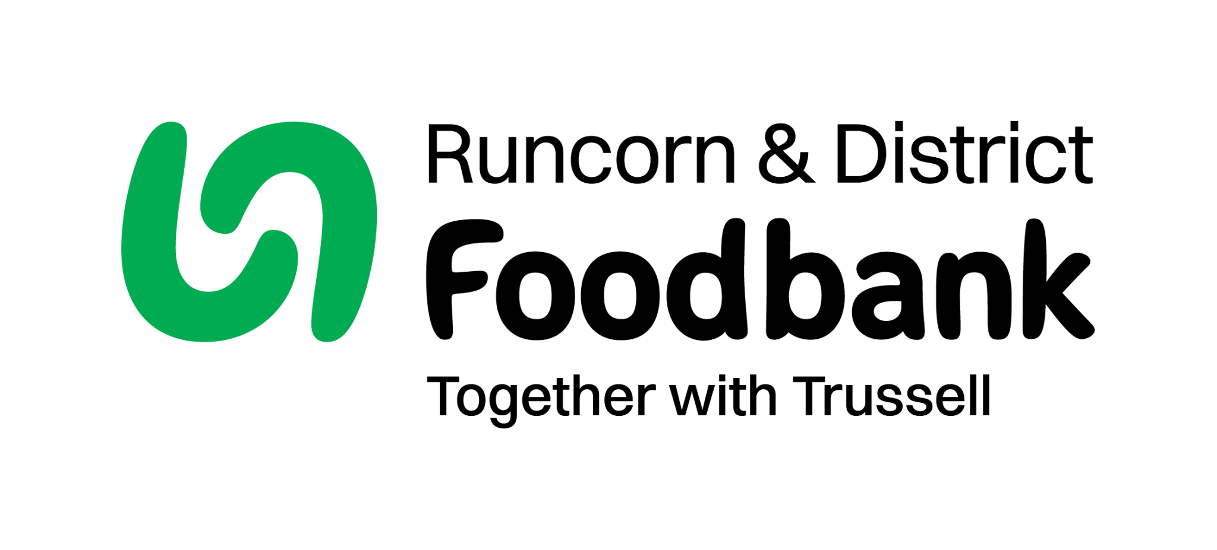
Runcorn and District Foodbank
53a Russell Road
Runcorn
Cheshire
WA7 4BH
01928 577679
info@runcorndistrict.foodbank.org.uk
www.runcorndistrict.foodbank.org.uk

CONFIDENTIALITY AGREEMENT

Name:

Date

Parties to this agreement:

Runcorn and District Foodbank
Operations Centre, 53A Russell Road, Runcorn WA7 4BH

While working with or employed by Runcorn and District Foodbank, in either a volunteer, self-employed or paid capacity:

- You will receive personal, financial and project information relating to its donors, clients, including identity, partners and beneficiary groups, which is considered to be confidential to the charity or the owner of that information.

- You are given access to this information in order that you may carry out your duties working or volunteering with the charity.

It is hereby agreed:

- While working with the charity in either a paid, self-employed or a volunteer capacity and after termination (however caused) of work, you will observe strict secrecy as to the affairs of Runcorn and District Foodbank. This particularly covers client identity, information on the charity, partners and projects.

- This information will not be divulged to a third party (except another charity member authorised to receive this information) during your work with the charity or after you finish working with the charity except in the proper course of your duties or with the written permission of the Trustees or management group.

- You will not remove from the charity without authority or allow others to remove, or copy the contents of documents, computer disks, tape, or tangible items, which contain the charities information or belong to the charity.

- You will return to the charity on request and particularly upon termination or end of working with the charity all documents, computer discs, tapes, photographs and other tangible assets

in your possession or under your control, which belong to the charity or which contain or refer to any confidential information.

- If you have Runcorn and District Foodbank information on a personal computer, CD, tape or disk or under your control you agree to delete or return it.

- You will keep client identity secret. The exception to this is where you are subject to law to declare it. (For example where there is compelling evidence of a serious crime, act of terrorism, or offences against children.) You will not copy client records.

- I have read the charities confidentiality agreement dated today’s date and agree to abide by it and I understand my responsibilities. I understand breaches may constitute Gross Misconduct and could result in dismissal, termination of paid or volunteering employment with the charity/and prosecution.

Signed Date

Name

Witnessed by:

This should be witnessed by your team leader or the Foodbank Manager if you are a team leader.

Signed: Date:

Name:

On behalf of Runcorn and District Foodbank

